**Health care Cost Analysis**

**Question 1**. To record the patient statistics, the agency wants to find the age category of people who frequently visits the hospital and has the maximum expenditure.

**Solution 1**.

The as. factor () is called to make sure that the categories are not treated as numbers. The package “ggplot2” is used to display the histogram.

**Code**:

library(readxl) # To read an excel file.

Hospital <- read_excel ("D:/Simplilearn/Project Data Sets/7/Hospital.xlsx")

# Location of excel file.

View (Hospital) # To view the inputted dataset.

Hospital # To get the tibble 6*6 in the console.

library(dplyr)

library(ggplot2)

# To find the category that has the Highest frequency of hospital visits

hist (Hospital$AGE, main = “Frequency of patients”, col = “green”, xlab = “Age”, ylab = “No of visits”)

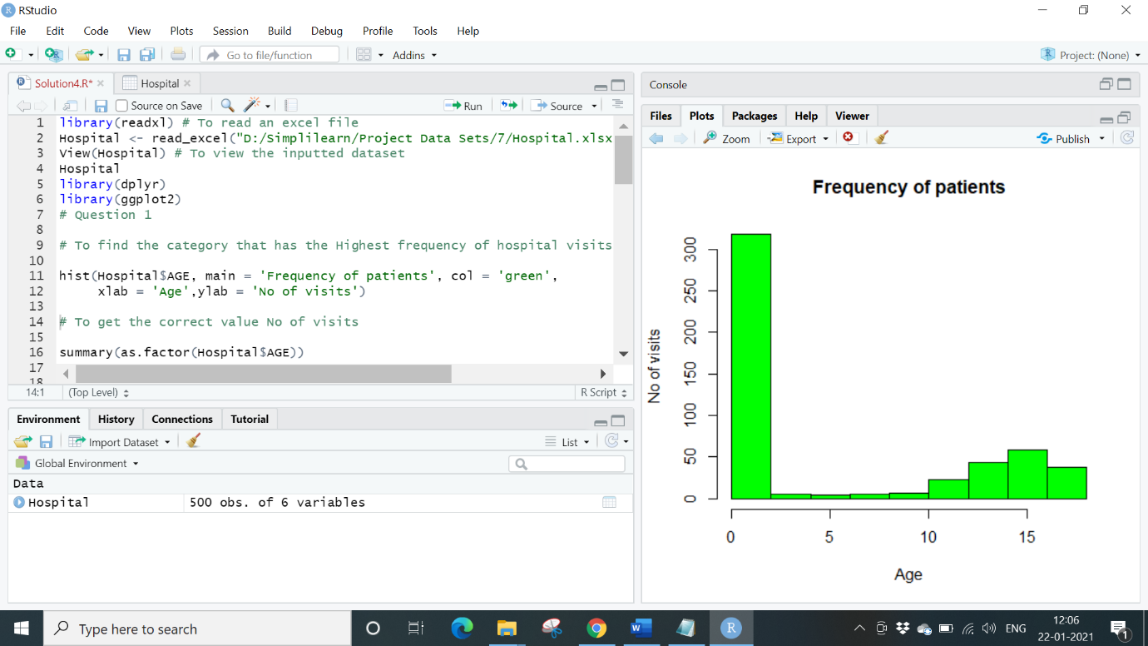

# To get the correct value No of visits

summary (as. factor (Hospital$AGE))

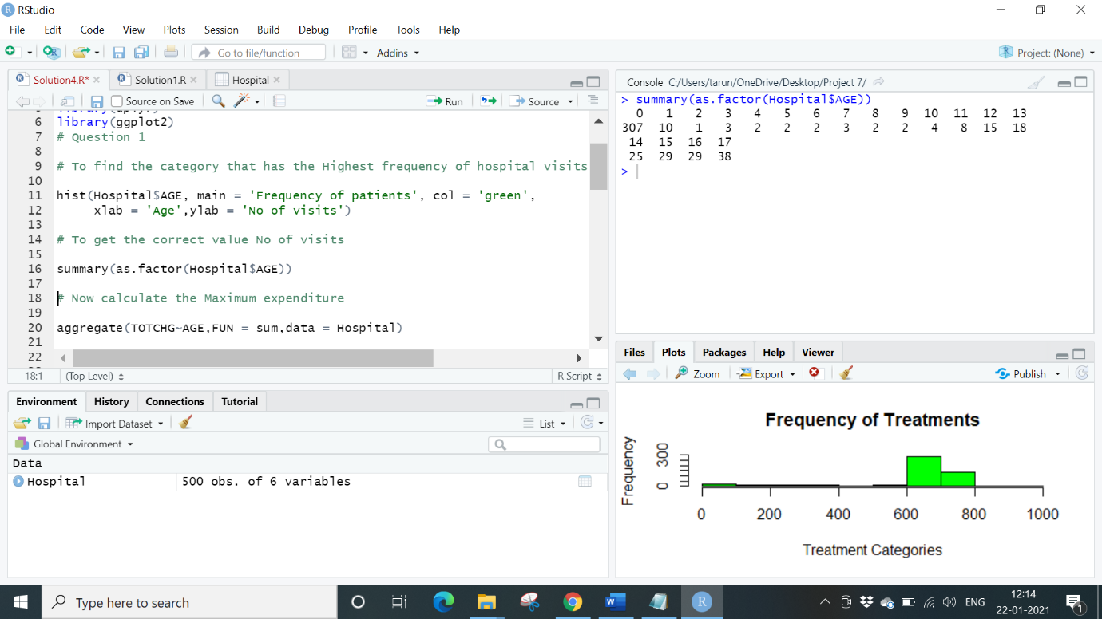

**Conclusion**:

From the graph that is displayed, we can see that (0) infants have the maximum frequency of hospital visit.

Now to calculate maximum expenditure:

Aggregate function is used to add the expenditure from each age and then max function used to find highest costs.

**Code**:

aggregate (TOTCHG~AGE, FUN=sum, data = Hospital)

max (aggregate (TOTCHG~AGE, FUN=sum, data = Hospital))

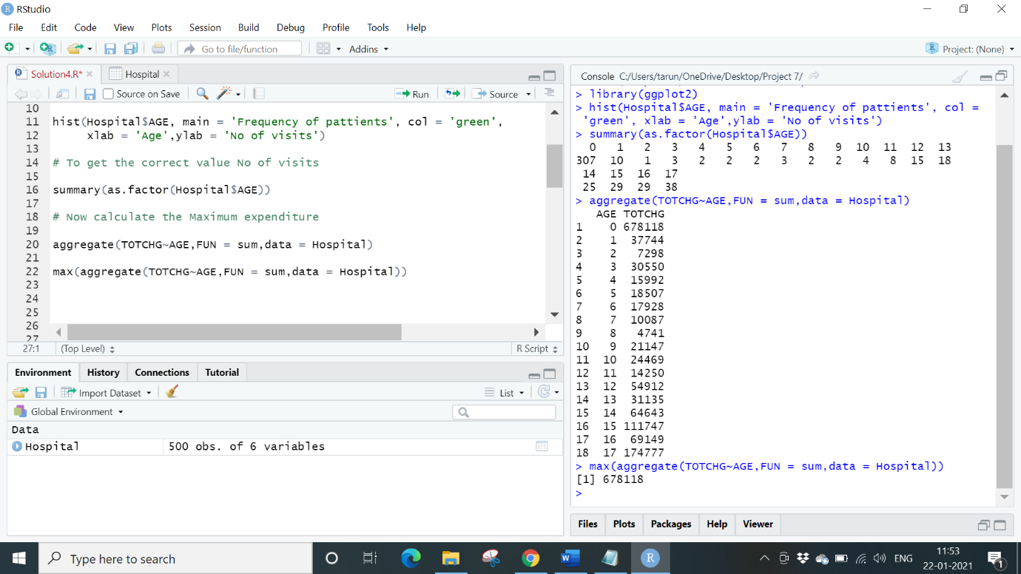

**Conclusion:**

So again, result is age group 0 (infant) for maximum expenditure.

**Question 2**. In order of severity of the diagnosis and treatments and to find out the expensive treatments, the agency wants to find the diagnosis related group that has maximum hospitalization and expenditure.

**Solution 2**.

**Code**:

hist (Hospital$APRDRG, col = 'green’, main = 'Frequency of Treatments',

xlab = 'Treatment Categories', ylab ='Frequency’)

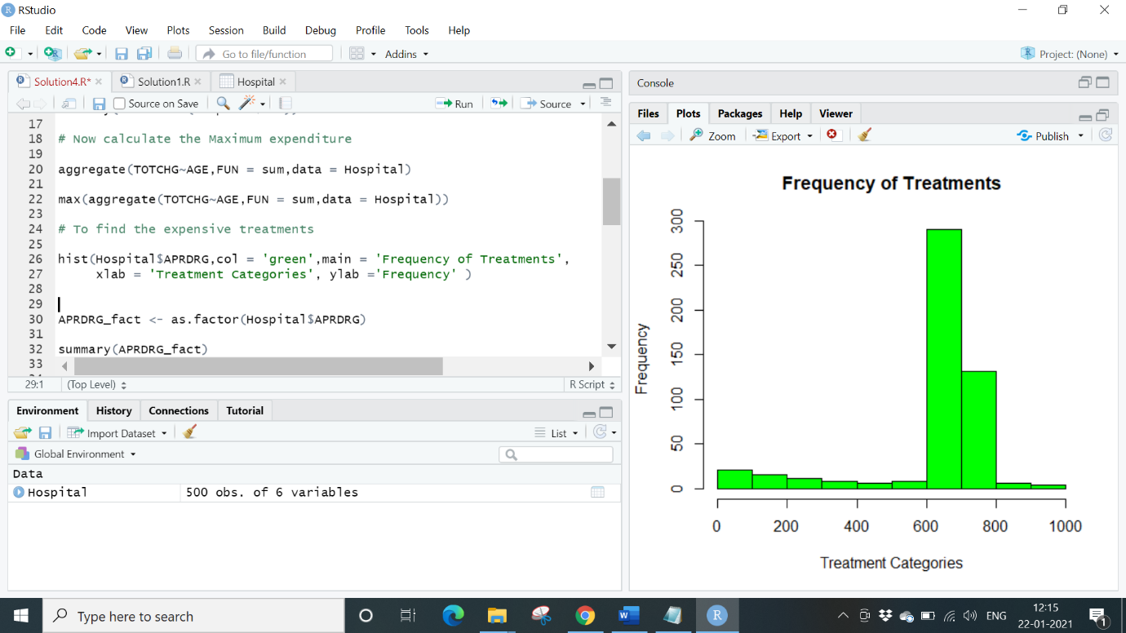

The as. factor () is called to make sure that the categories are not treated as numbers.

**Code**:

APRDRG_fact<-as. factor (Hospital$APRDRG)

summary (APRDRG_fact)

which.max (summary (APRDRG_fact))

df <-aggregate (TOTCHG~APRDRG, FUN = sum, data=hospital)

df

df[which.max(df$TOTCHG),]

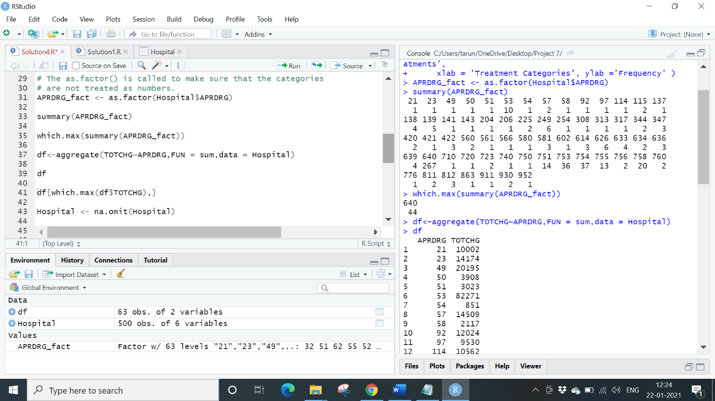

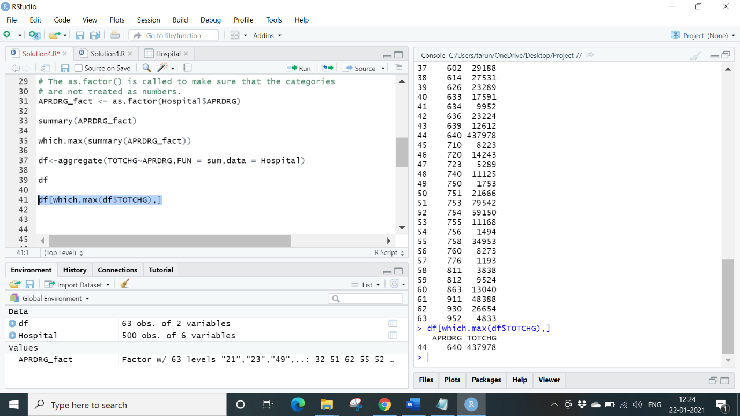

**Conclusion**: So, the category 640 has the maximum hospitalizations along with this it also has the highest hospitalization cost.

**Question 3**. To make sure that there is no malpractice, the agency needs to analyze if the race of the patient is related to the hospitalization costs.

**Solution 3**.

Remove the “NA” values from our database, then by using as.factor() the Race variable to generate a summary to verify whether race made an impact on the hospital costs we will use ANOVA function with TOTCHG as dependent variable and RACE as grouping variable.

**Code**:

Hospital <-na. omit(hospital) #first we remove “NA” values

Hospital$RACE<-as. factor (Hospital$RACE)

model_aov<-aov (TOTCHG~RACE, data = Hospital)

model_aov #ANOVA RESULTS

summary(model_aov)

summary (Hospital$RACE)

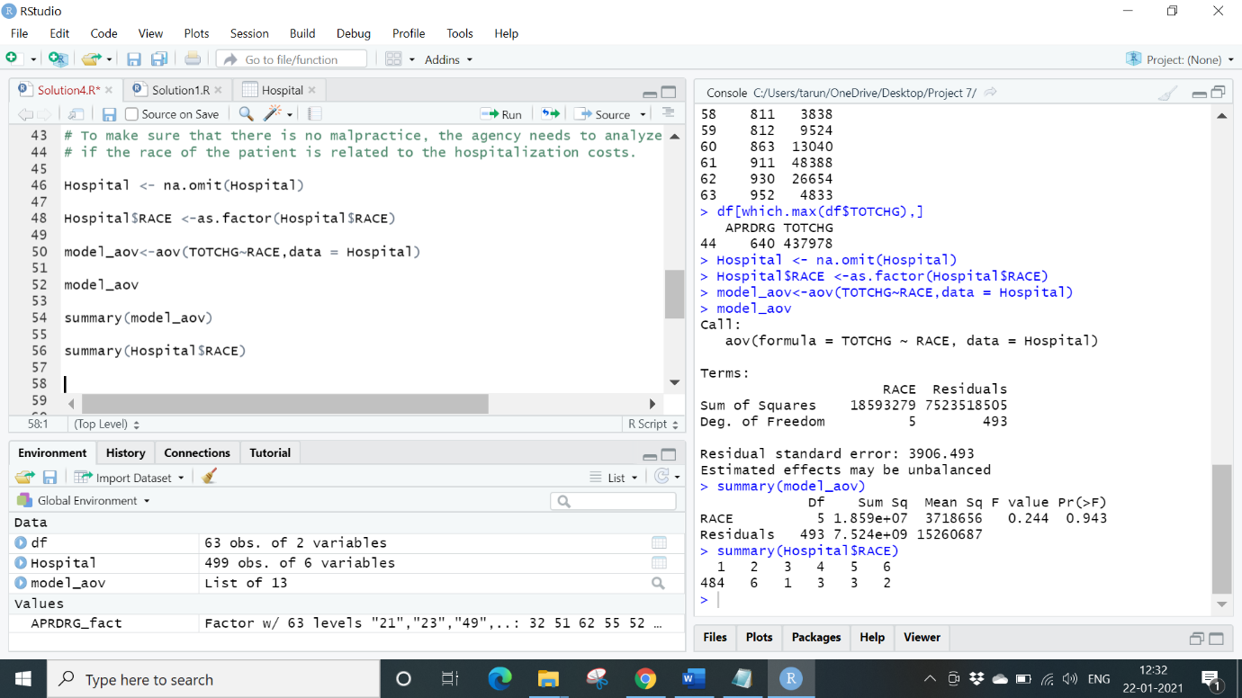

**Conclusion**: The result shows that there is no relationship between race and hospital costs, thereby accepting the Null hypothesis.

**Question 4**. To properly utilize the costs, the agency has to analyze the severity of the hospital costs by age and gender for proper allocation of resources.

**Solution 4**.

To analyze the costs we will use linear regression with TOTCHG(Cost) and independent variable along with AGE and Female as dependent variables

**Code**:

Hospital$FEMALE <- as. factor (Hospital$FEMALE)

model_lm1 <- lm (TOTCHG~AGE+FEMALE, data =Hospital) #calling Regression function

summary(model_lm1)

summary(hosp$FEMALE) #comapring genders

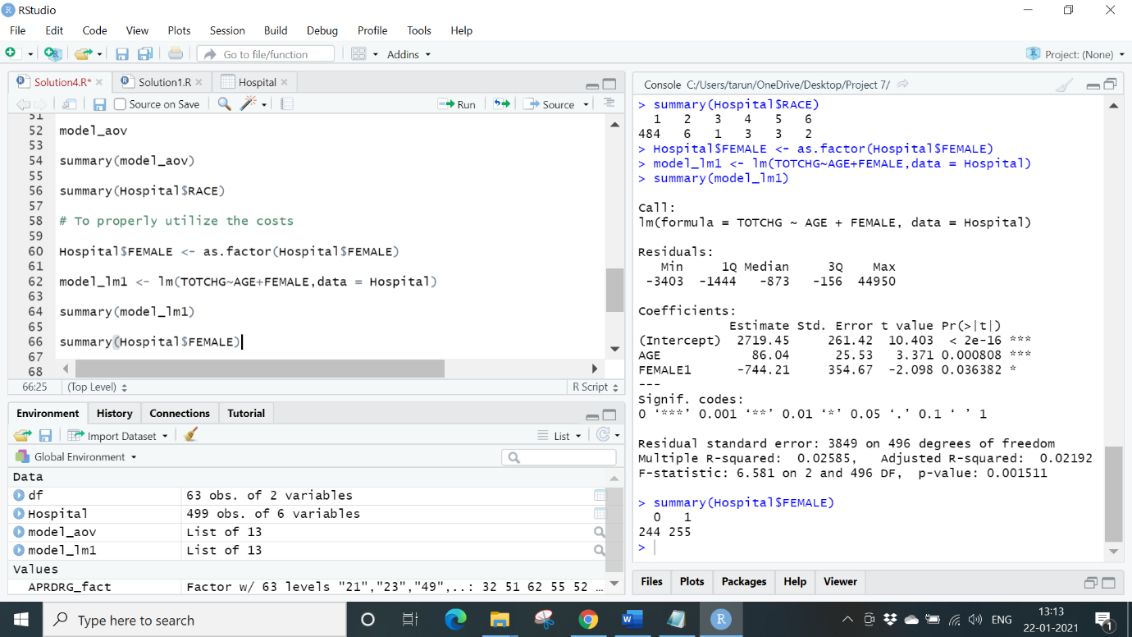

**Conclusion**: There are equal number of Females and Males and on an average (based on the negative coefficient values) females makes lesser hospital costs than males.

**Question 5**. Since the length of stay is the crucial factor for inpatients, the agency wants to find if the length of stay can be predicted from age, gender, and race.

**Solution 5**.

To find the length of stay we are using linear regression. Here length of stay is the dependent variable and age, gender and race are independent variables

**Code**:

Hospital$RACE <- as. factor (Hospital$RACE)

model_lm2 <- lm (LOS~AGE+FEMALE+RACE, data = Hospital)

summary(model_lm2)

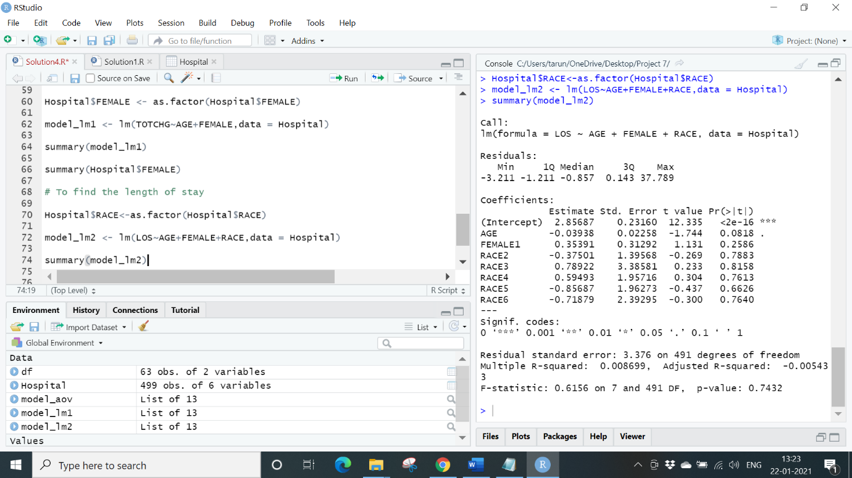

**Conclusion**: All independent variables are quite high thus signifying that there is no linear relationship between the given variables, so we can’t predict length of stay of a patient based on age, gender and race.

**Question 6**. To perform a complete analysis, the agency wants to find the variable that mainly affects the hospital costs.

**Solution 6**. To find the variable that mainly affects the hospital costs we use linear regression thus TOTCHG becomes dependent rest all becomes independent.

**Code**:

model_lm3 <- lm (TOTCHG~AGE+FEMALE+RACE+LOS+APRDRG, data = Hospital)

summary(model_lm3)

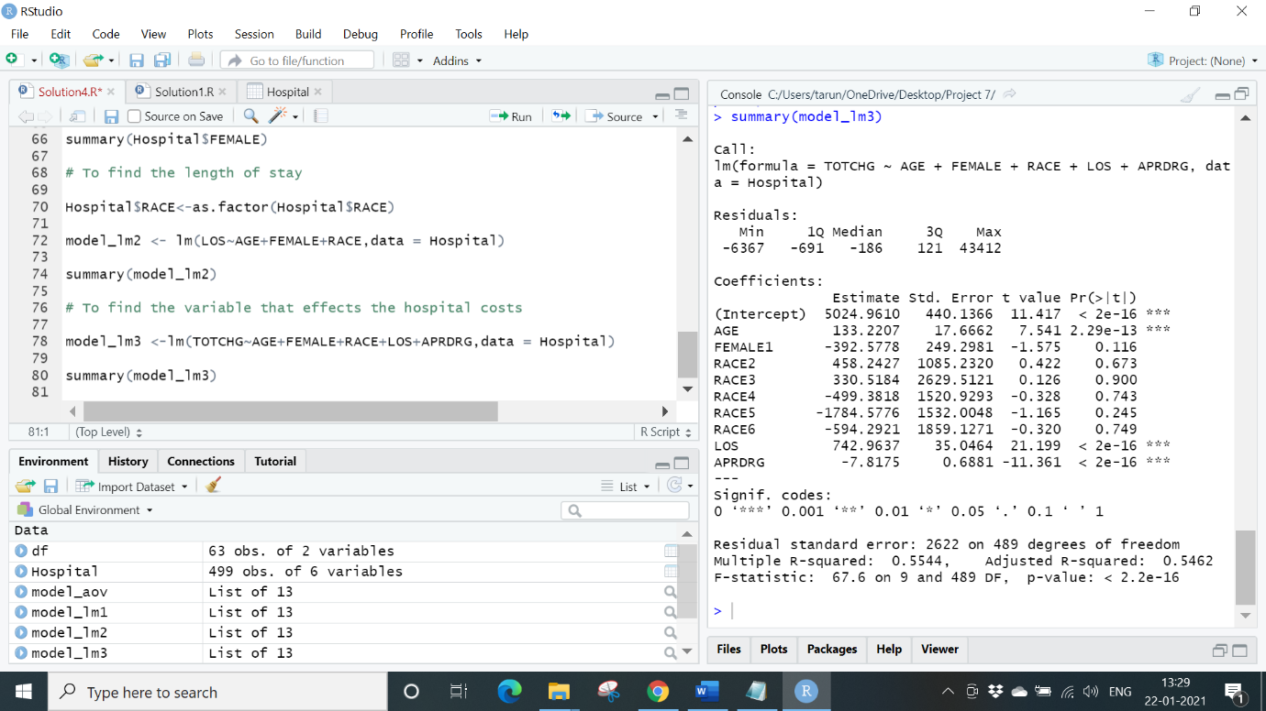

**Conclusion**: Age and Length of stay affect the total hospital costs.

**Code**:

library(readxl) # To read an excel file

Hospital <- read_excel ("D:/Simplilearn/Project Data Sets/7/Hospital.xlsx")

# Location of excel file

View (Hospital) # To view the inputted dataset

Hospital

library(dplyr)

library(ggplot2)

# Question 1

# To find the category that has the highest frequency of hospital visits and has

the maximum expenditure.

hist (Hospital$AGE, main = 'Frequency of patients', col = 'green',

xlab = ‘Age’, ylab = 'No of visits')

# To get the correct value No of visits.

summary (as. factor (Hospital$AGE))

# Now calculate the Maximum expenditure.

aggregate (TOTCHG~AGE, FUN = sum, data = Hospital)

max (aggregate (TOTCHG~AGE, FUN = sum, data = Hospital))

# Question 2

# To find out the expensive treatments

hist (Hospital$APRDRG, col = ‘green’, main = 'Frequency of Treatments',

xlab = 'Treatment Categories', ylab ='Frequency’)

# The as. factor () is called to make sure that the categories are not treated as numbers.

APRDRG_fact <- as. factor (Hospital$APRDRG)

summary (APRDRG_fact)

which.max (summary (APRDRG_fact))

df <- aggregate (TOTCHG~APRDRG, FUN = sum, data = Hospital)

df

df[which.max(df$TOTCHG),]

# Question 3

# To make sure that there is no malpractice, the agency needs to analyze if the race of the patient is related to the hospitalization costs.

Hospital <- na. omit (Hospital)

Hospital$RACE <-as. factor (Hospital$RACE)

model_aov<-aov (TOTCHG~RACE, data = Hospital)

model_aov

summary(model_aov)

summary (Hospital$RACE)

# Question 4

# To properly utilize the costs

Hospital$FEMALE <- as. factor (Hospital$FEMALE)

model_lm1 <- lm (TOTCHG~AGE+FEMALE, data = Hospital)

summary(model_lm1)

summary (Hospital$FEMALE)

# Question 5

# To find the length of stay

Hospital$RACE<-as.factor (Hospital$RACE)

model_lm2 <- lm (LOS~AGE+FEMALE+RACE, data = Hospital)

summary(model_lm2)

# Question 6

# To find the variable that effects the hospital costs

model_lm3 <- lm (TOTCHG~AGE+FEMALE+RACE+LOS+APRDRG, data = Hospital)

summary(model_lm3)

(End of Project)